Demonstrations ACM « Large Scale »

# Hardware platforms

## Raspberry Pi Zero WH

16 plaforms

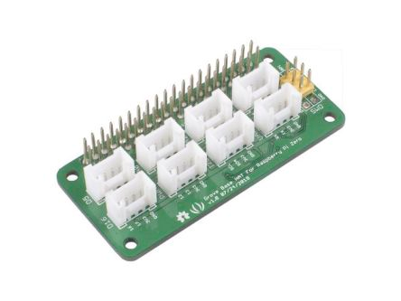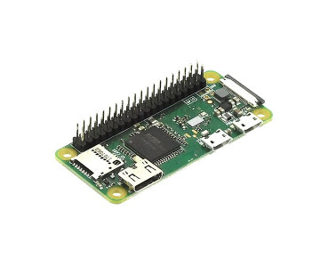

## Grove Base Hat

17 platforms

* 2 Digital ports
* 3 Analog ports
* 1 PWM port
* 1 I2C port (chainable with Grove I2C hub)
* 1 UART port

**Caution**: Number of connected sensors or actuators to Grove Base Hat platform is limited to available port types. Eventually, 1 or 2 extra digital actuator / sensors can be connected using specific connector cables (to directly connect them to Raspberry Pi GPIO).

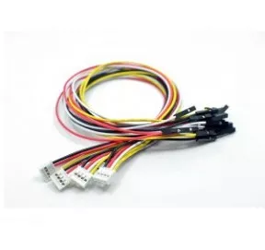

# Sensors and Actuators List (available and functional ones)

## Sensors

|  |  |  |  |
| --- | --- | --- | --- |
|  | **Description** | **Nb Available** | **Price TTC** |
| https://raw.githubusercontent.com/SeeedDocument/Grove-Red_LED_Button/master/img/main.jpg | **Grove - LED Button**  Digital (on/off) | 16 | 2,60€ |
| Module potentiomètre Grove 101020048 | **Grove – Rotary Angle Sensor**  Analog | 3 | 3,05€ |
| https://cdn-reichelt.de/bilder/web/artikel_ws/A300/101020014_1.jpgenter image description here | **Grove – Light Sensor (v1.1 or v1.2)**  Analog | 2 | 3,05€ |

## Actuators

|  |  |  |  |
| --- | --- | --- | --- |
|  | **Description** | **Nb Available** | **Price TTC** |
| https://github.com/SeeedDocument/Grove-LED_Socket_Kit/raw/master/img/Grove-White-LED-p-2016.jpeg | **Grove - LED Socket**  Digital (on/off) ou PWM (blinking or fading) | 4 | 2,05€ |
| https://raw.githubusercontent.com/SeeedDocument/Grove-Red_LED_Button/master/img/main.jpg | **Grove - LED Button**  Digital (on/off) | 16 | 2,60€ |
| https://boutique.semageek.com/616-large_default/module-led-rgb-chainable-grove.jpg  https://github.com/SeeedDocument/Grove-Chainable_RGB_LED/raw/master/img/Grove-Chainable_RGB_LED_V2.0.jpg | **Grove – Chainable RGB Led**  Digital (multiple colours)  Can chain several ones, but code not tested on more than one per platform for the moment. | 9 | 6,50€ |
|  | **Grove – Mini Fan**  Digital | 1 | 9,95€ |
| https://raw.githubusercontent.com/SeeedDocument/Grove-4-Digit_Display/master/img/Grove-4_digit_display.jpg | **Grove – 4 Digits Display**  Digital | 12 | 6,20€ |

# Sensors and Actuators List (available but not tested ones)

## Actuator

|  |  |  |  |
| --- | --- | --- | --- |
|  | **Description** | **Nb Available** | **Price TTC** |
| https://github.com/SeeedDocument/Grove_PIR_Motion_Sensor/raw/master/img/Grove_-_PIR_Motion_Sensor.jpg | **Grove – PIR Motion Sensor**  Digital | **2** | **10,25€** |
| Capteur de couleur Grove 101020341 | **Grove – I2C Colour Sensor**  I2C  Code to develop to use it | **0** | **10,90€** |
| https://github.com/SeeedDocument/Grove_Buzzer/raw/master/images/Grove%20Buzzer.jpg | **Grove- Buzzer**  Digital | **1** | **2,10€** |